LeetCode Exercises - GROUP BY Problems
- 586. Customer Placing the Largest Number of Orders https://leetcode.com/problems/customer-placing-the-largest-number-of-orders

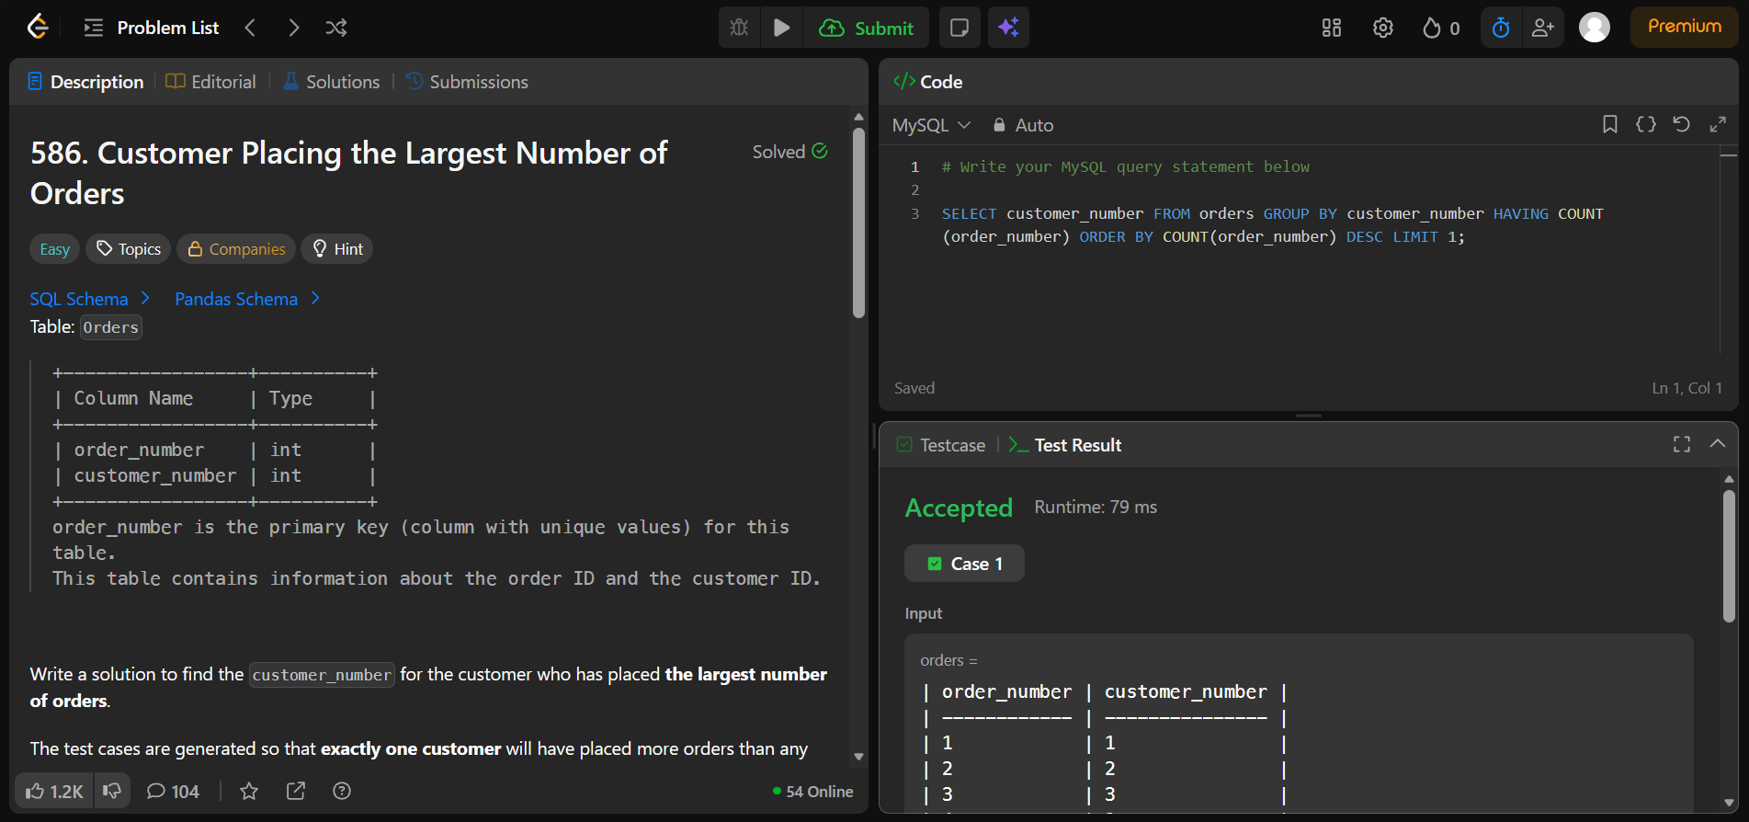

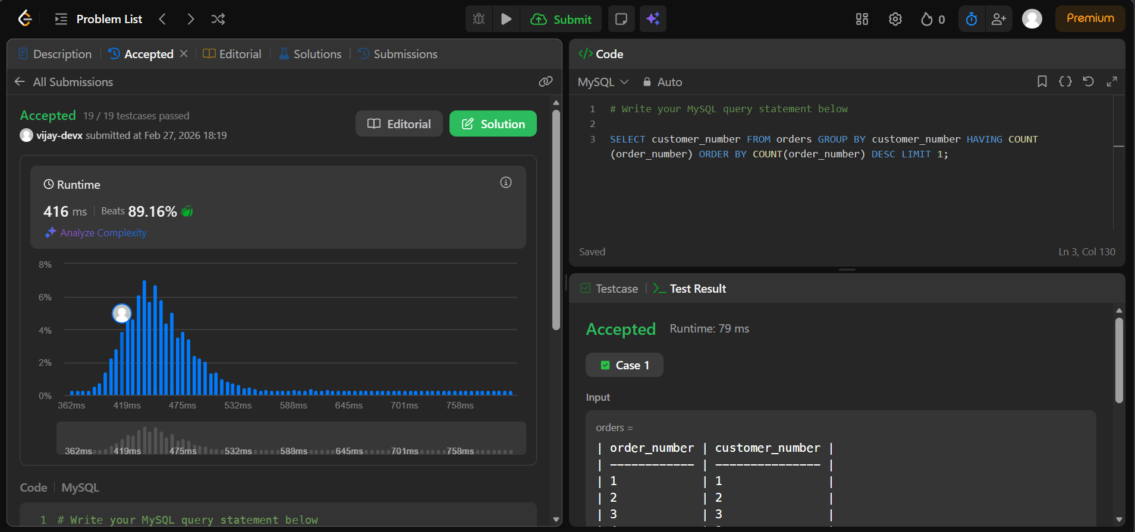

- 619. Biggest Single Number https://leetcode.com/problems/biggest-single-number

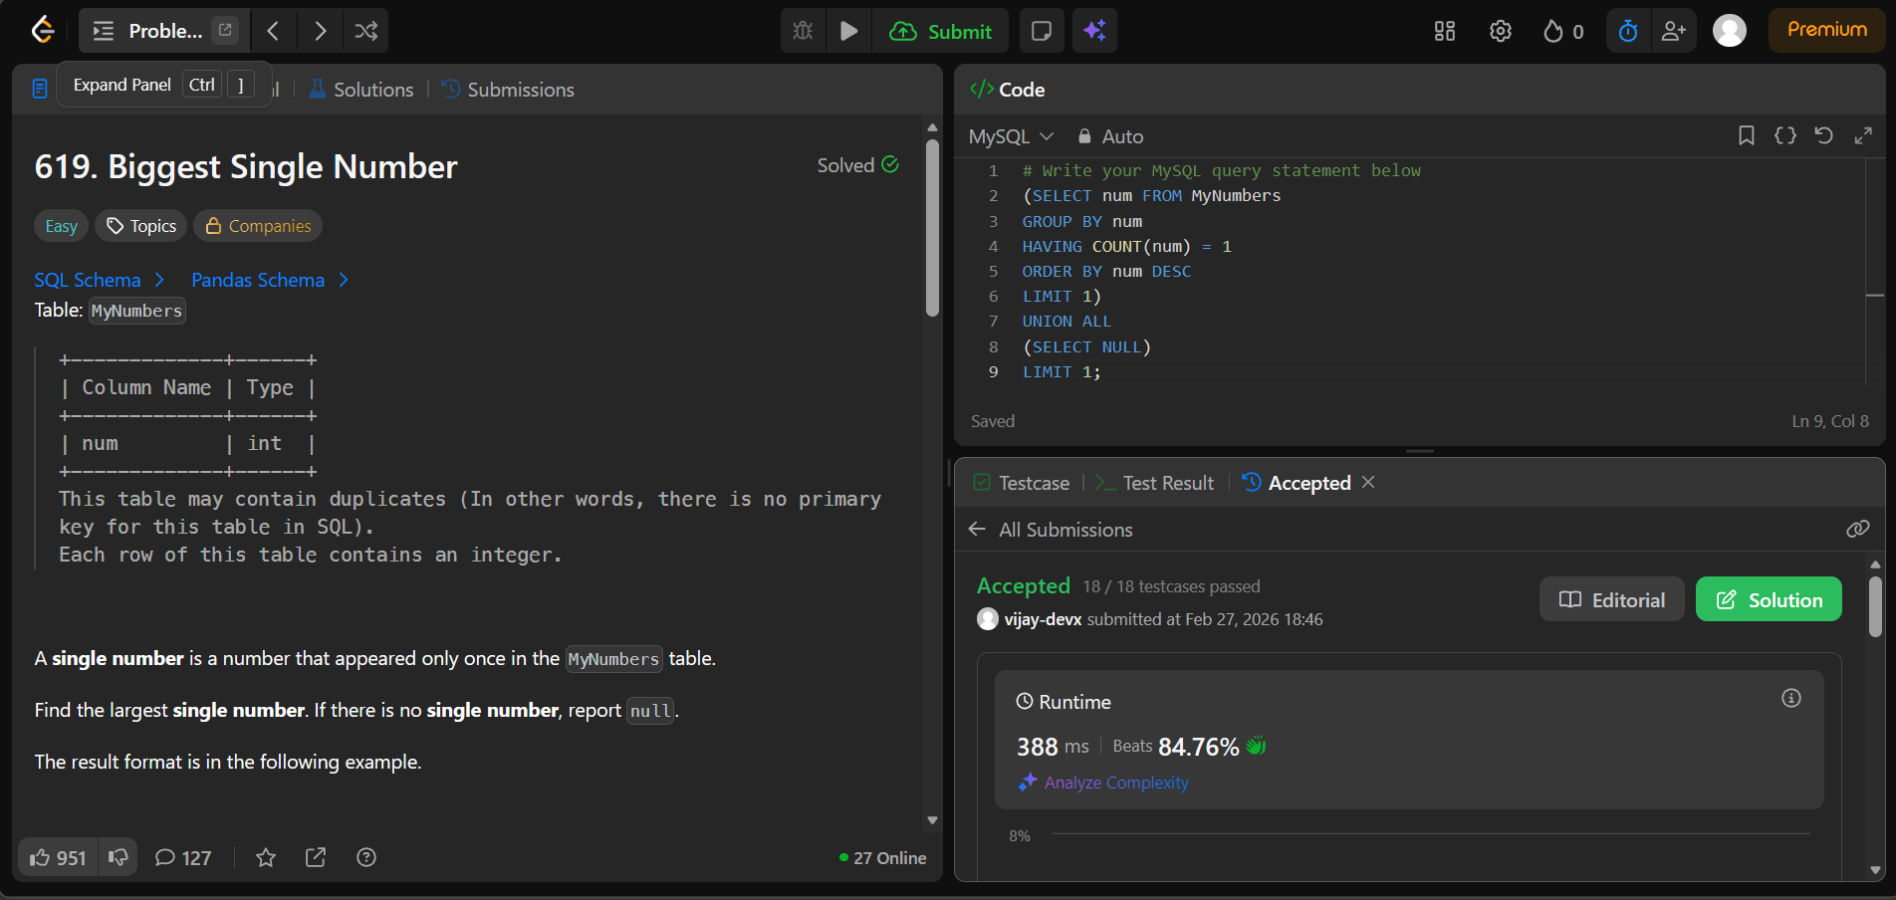

- 511. Game Play Analysis I https://leetcode.com/problems/game-play-analysis-i

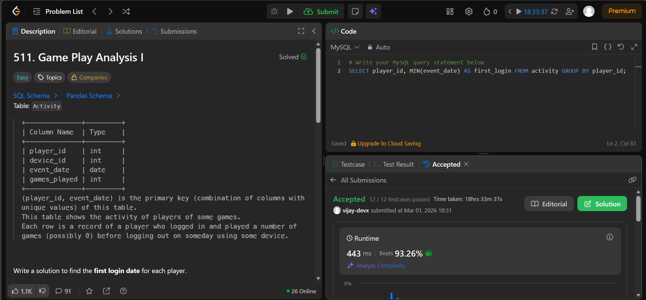

- 1693. Daily Leads and Partners https://leetcode.com/problems/daily-leads-and-partners

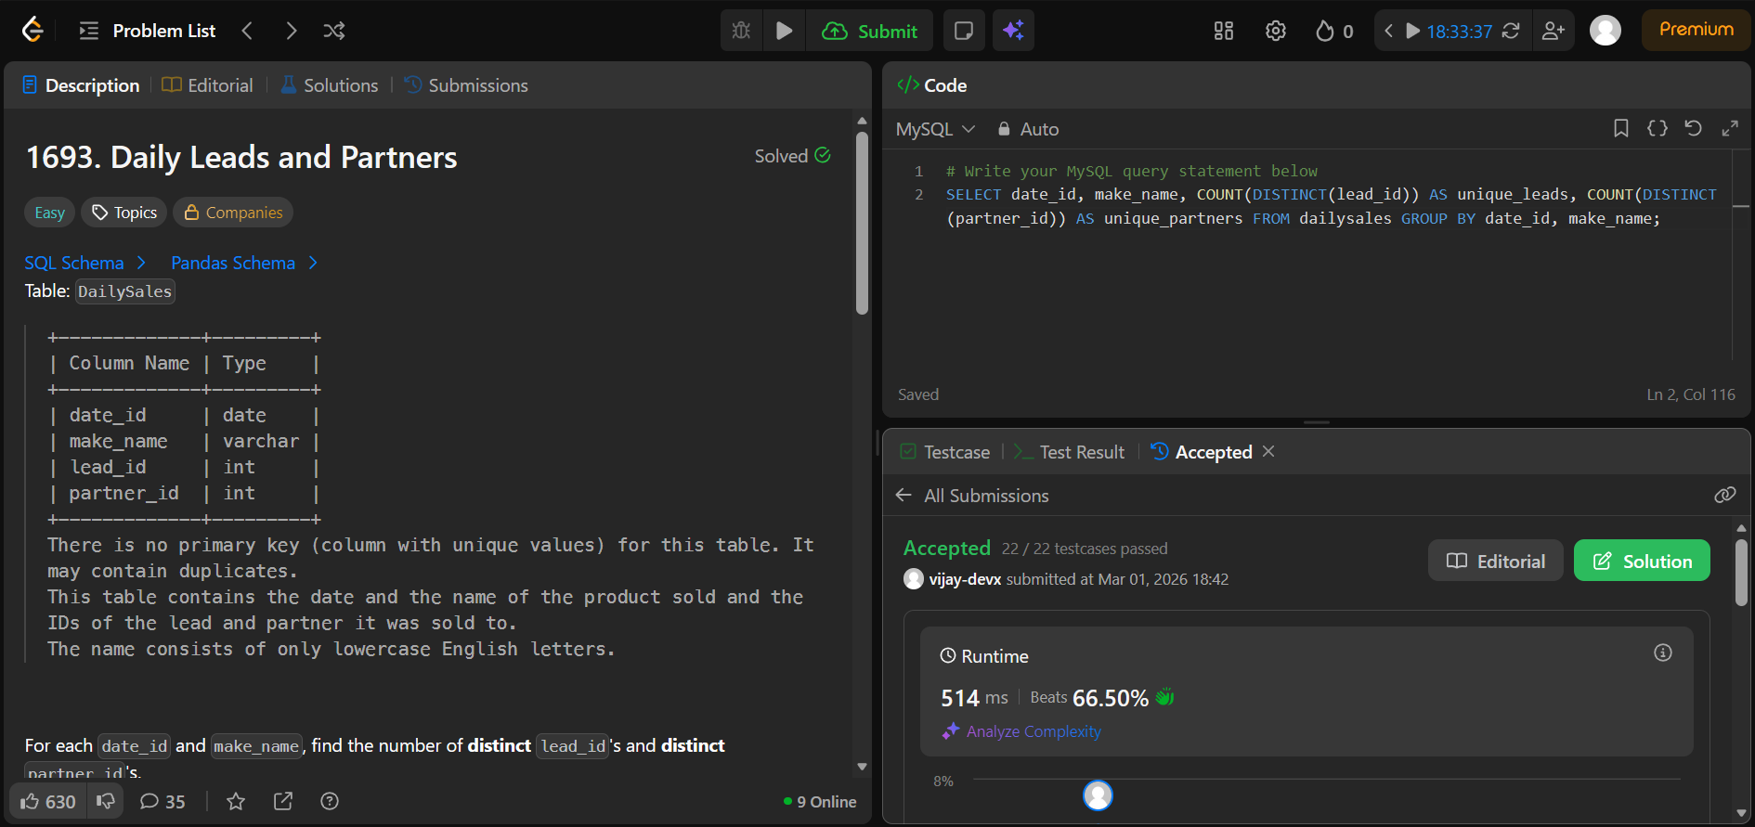

- 1741. Find Total Time Spent by Each Employee https://leetcode.com/problems/find-total-time-spent-by-each-employee

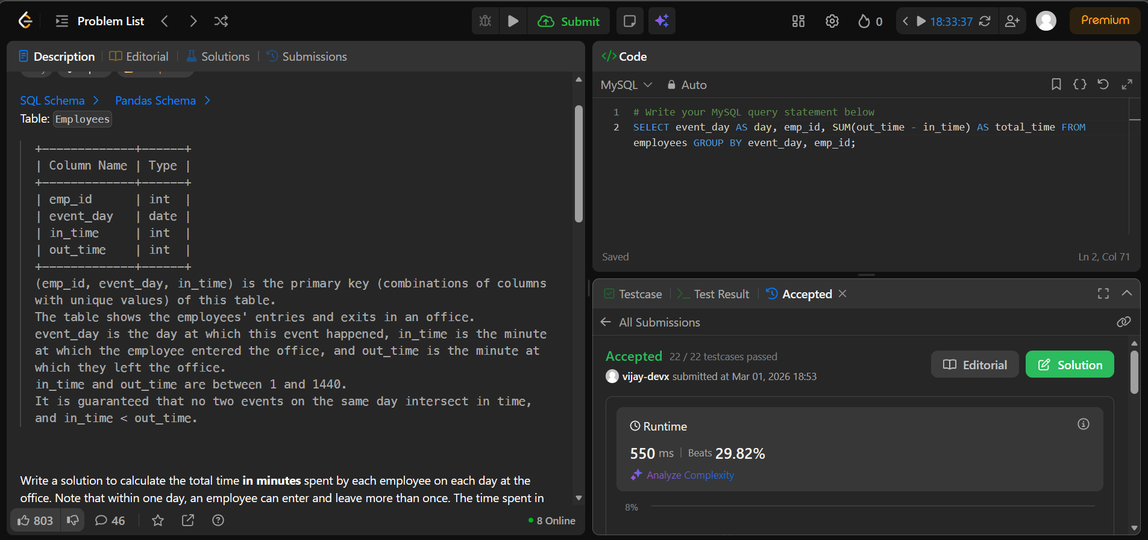

- 1050. Actors and Directors Who Cooperated at Least Three Times https://leetcode.com/problems/actors-and-directors-who-cooperated-at-least three-times

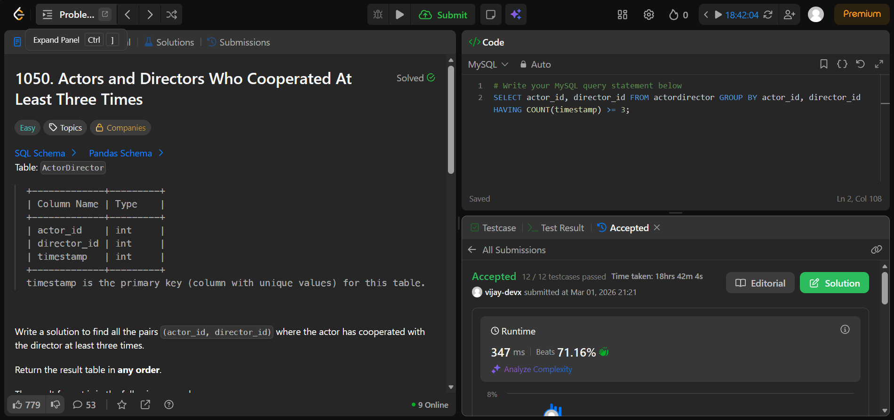

- 1890. The Latest Login in 2020 https://leetcode.com/problems/the-latest-login-in-2020

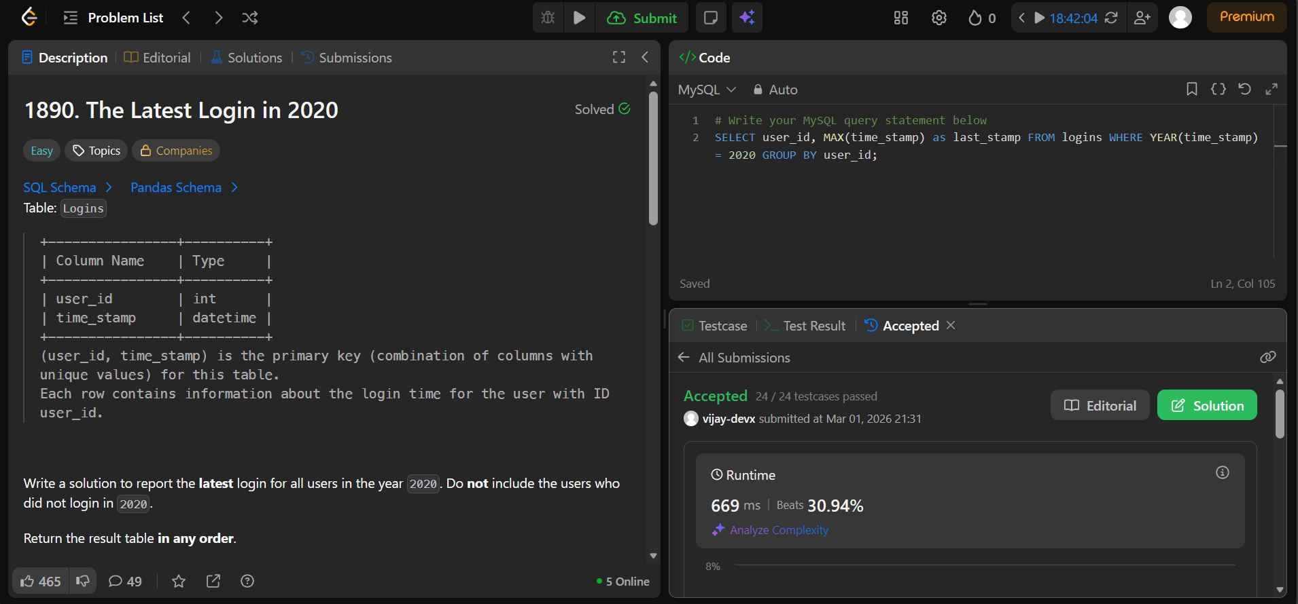

- 1211. Queries Quality and Percentage https://leetcode.com/problems/queries-quality-and-percentage

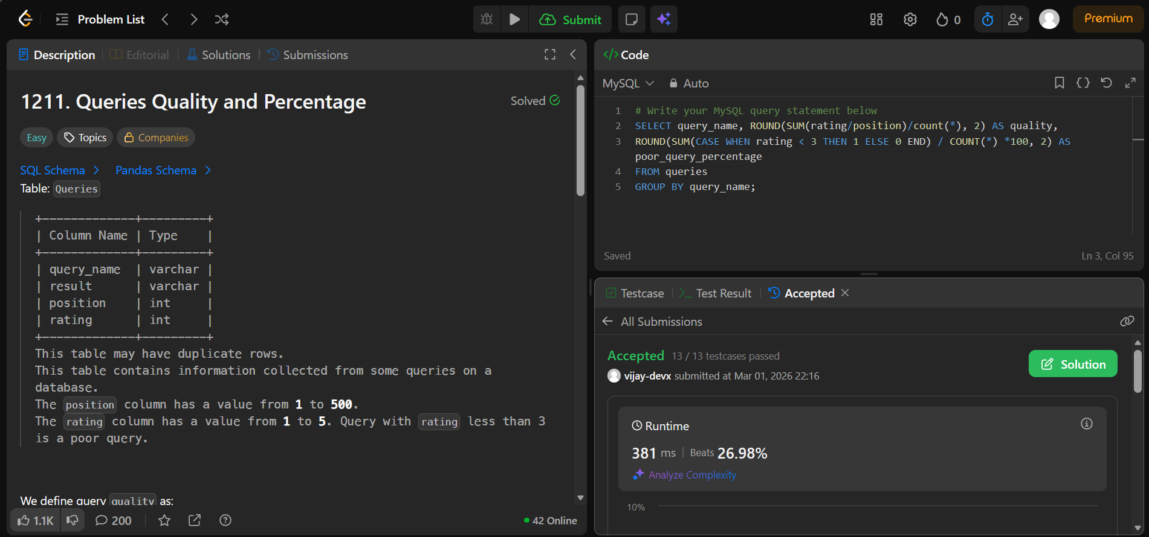

- 1141. User Activity for the Past 30 Days I https://leetcode.com/problems/user-activity-for-the-past-30-days-i

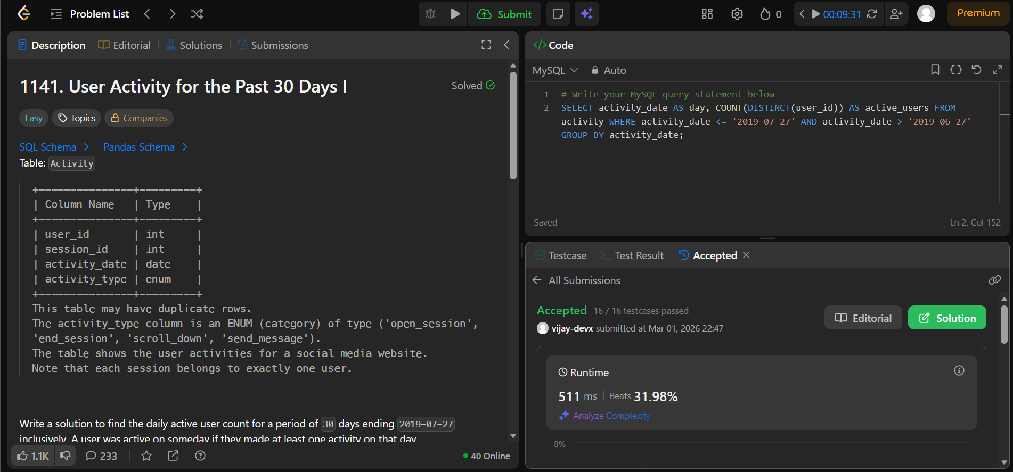

- 596. Classes With At Least 5 Students https://leetcode.com/problems/classes-with-at-least-5-students

